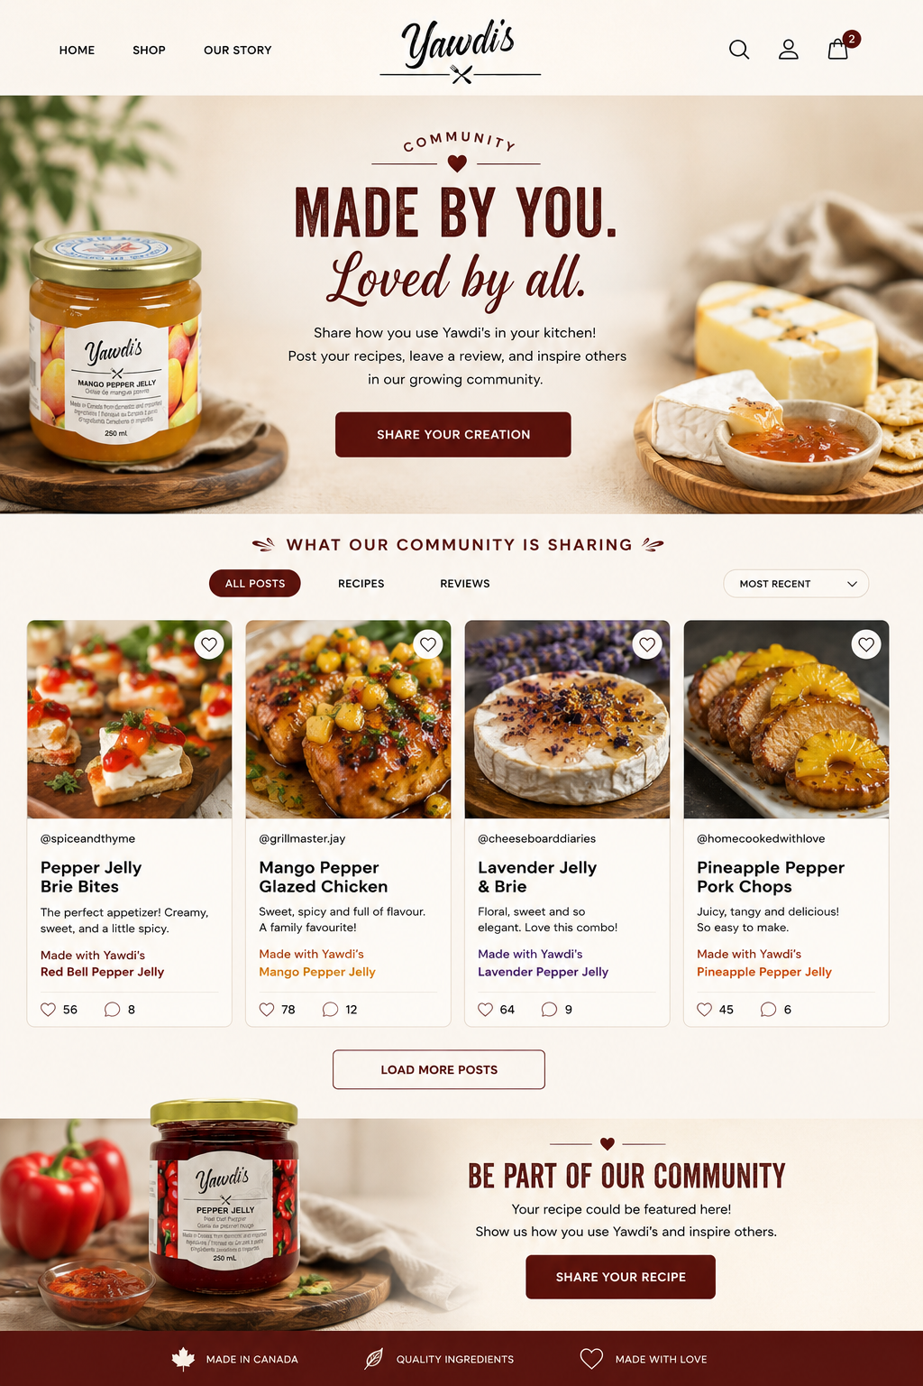
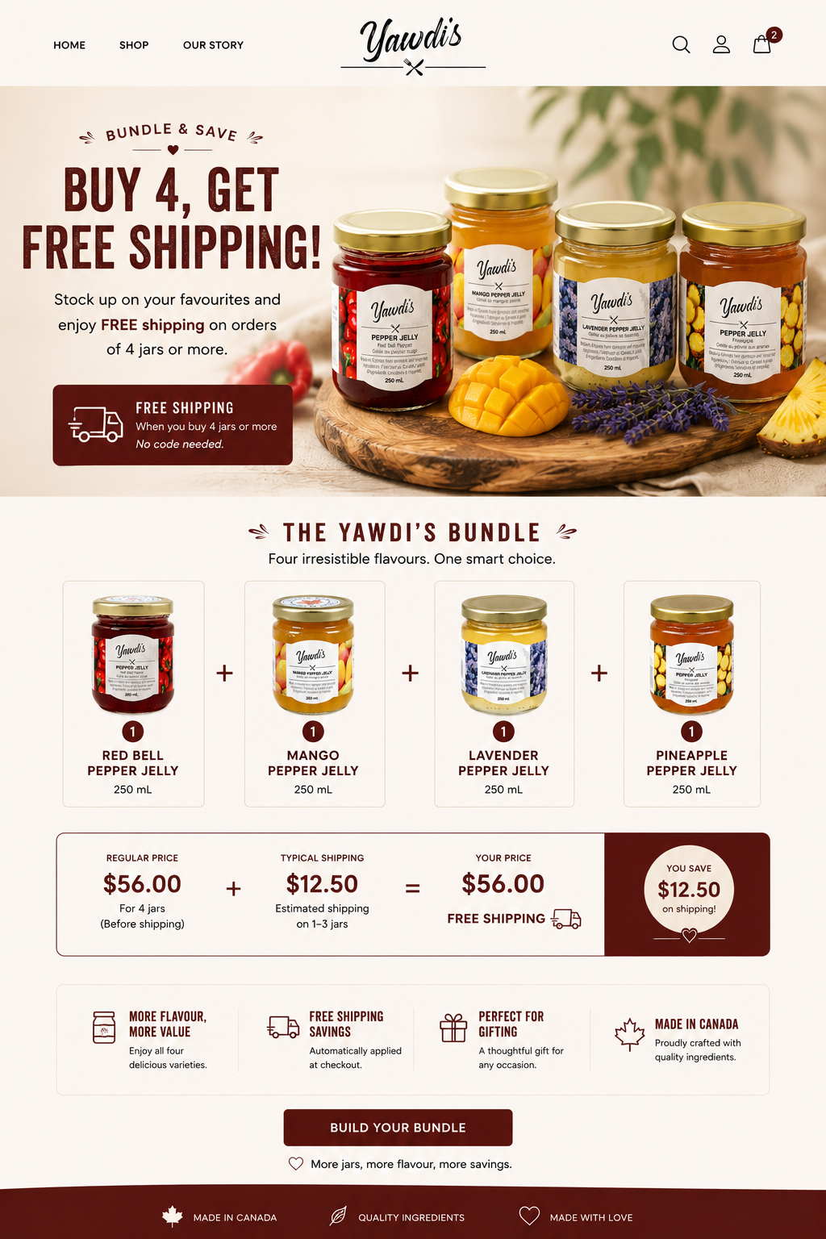



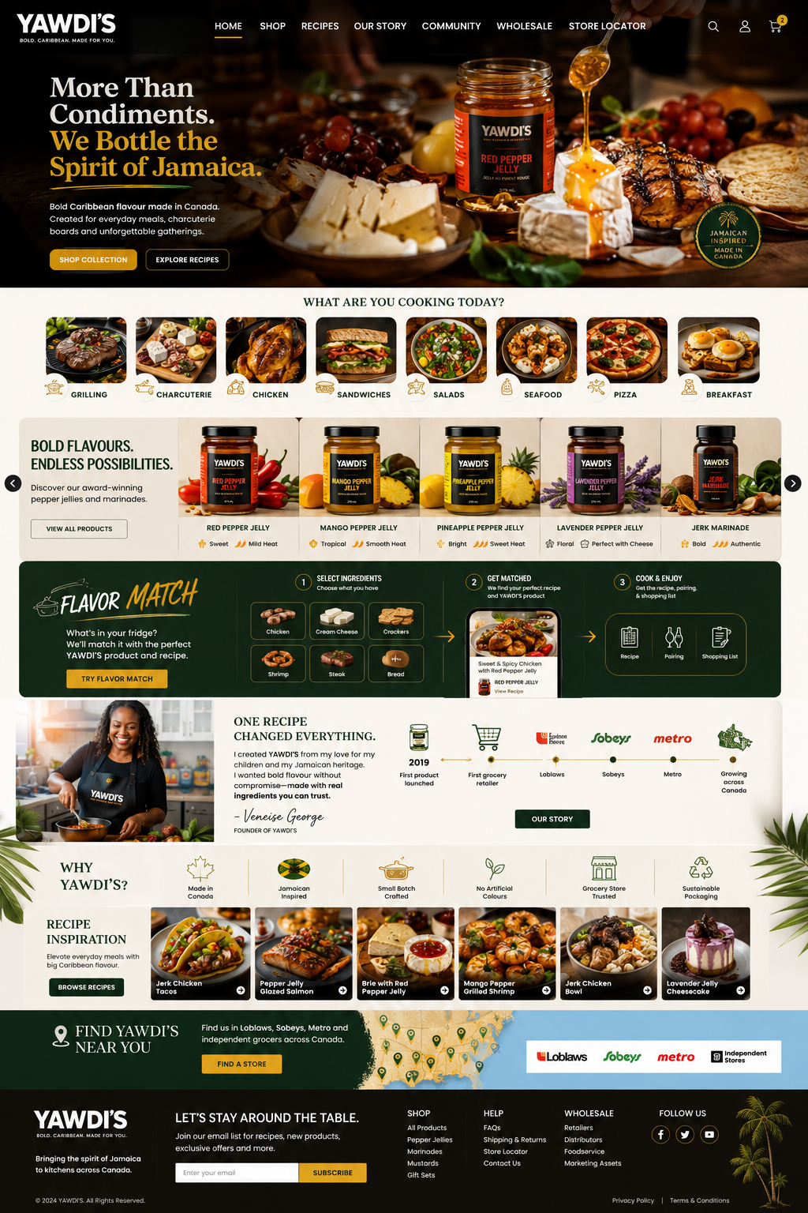

Homepage Flow
YAWDI'S
Sun, Spice & Everything Nice

Rooted in Jamaica. Made for Every Table
- Hero Experience
Headline
Bold Flavour. Real Ingredients. Dinner in Minutes.
Sub-headline
Yawdi's pepper jellies and jerk marinades bring true island flavour to your table — real Scotch bonnet peppers, no shortcuts, no fillers. Just the real ting.
Supporting Line
One jar. A hundred ways to use it. Zero prep time required
- What are you cooking?
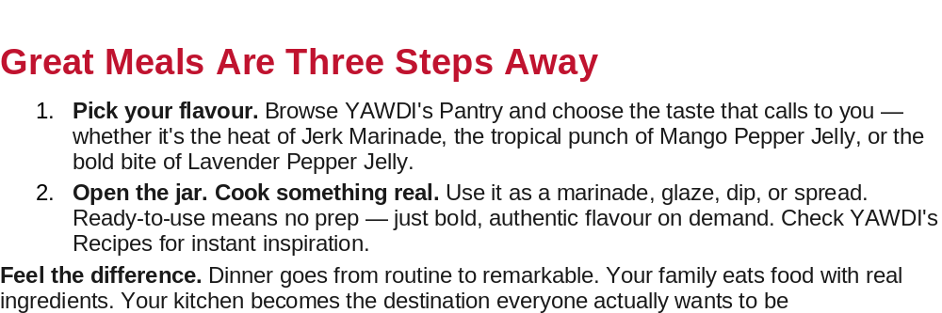
YAWDI'S Recipe Collection
This should almost function like a food blog. (how many recipes can be uploaded )
Each recipe contains (Preparation time, Difficulty, Ingredients, Products used, Nutrition, Video (Youtube link), Printable recipe, Share button)

Real Jamaican Heat, Bottled with Love
A full pantry-to-plate guide for Yawdi's Jerk Marinade and pepper jellies (Mango, Red Pepper, Pineapple, Lavender) — from the grill to the breakfast table.

1. Grilling Recipe Ideas
Jerk Marinade
Classic Jerk Chicken Marinate bone-in chicken thighs and drumsticks in Yawdi's Jerk Marinade. Grill over medium-high heat, turning often, 30–35 minutes until the skin is charred and the inside is juicy. Baste with extra marinade in the last 5 minutes.
Jerk Shrimp Skewers Toss peeled shrimp in Jerk Marinade for 20–30 minutes (don't over-marinate seafood). Thread onto skewers with red onion and bell pepper, grill 2–3 minutes per side until pink and slightly charred.
Jerk Pork Tenderloin Marinate whole pork tenderloin. Sear on all sides over high heat, then move to indirect heat to finish, about 20 minutes total, until internal temp hits 145°F. Rest 5 minutes before slicing.
Jerk Grilled Corn Brush shucked corn with a thin layer of Jerk Marinade before grilling. Finish with lime and a little flaky salt.

Mango Pepper Jelly
Mango Jelly Glazed Salmon Grill salmon skin-side down over medium heat. In the last 3–4 minutes, brush generously with warmed Mango Pepper Jelly for a sticky, caramelized glaze.
Grilled Mango Jelly Chicken Thighs Grill boneless chicken thighs plain, then toss in warmed Mango Pepper Jelly during the last few minutes so it caramelizes without burning.

Red Pepper Jelly
Red Pepper Jelly Glazed Pork Chops Season chops simply with salt and pepper, grill, and brush with Red Pepper Jelly in the final minutes for a glossy, sweet-tangy crust.
Red Pepper Jelly Ham Steaks Grill thick-cut ham steaks 2–3 minutes per side, glazing with Red Pepper Jelly at the end.

Pineapple Pepper Jelly
Pineapple Jelly Chicken Skewers Alternate chicken chunks and fresh pineapple on skewers, grill, then brush with warmed Pineapple Pepper Jelly for the last minute of cooking.
Pineapple Jelly Glazed Ribs Slow-grill ribs low and indirect, then finish with a heavy brush of Pineapple Pepper Jelly over direct heat to set a sticky glaze.

Lavender Pepper Jelly
Lavender Jelly Grilled Lamb Chops Grill lamb chops to your liking, then glaze with warmed Lavender Pepper Jelly in the last minute — the floral sweetness plays beautifully against the richness of the lamb.
Grilled Peaches with Lavender Jelly Halve peaches, grill cut-side down until char marks form, then drizzle with warm Lavender Pepper Jelly and a scoop of vanilla ice cream for a grill-to-dessert finish.

2. Charcuterie Board Ideas
- The Warm Brie Centerpiece — a wheel of warm brie topped with Mango, Red Pepper, or Lavender Pepper Jelly, surrounded by crackers, toasted baguette, and candied nuts.
- Jerk-Spiced Nuts — cashews or almonds tossed in a little oil and Jerk Marinade, roasted until fragrant, cooled, and scattered across the board.
- Sweet & Heat Cheese Pairings — pair a mild goat cheese with Lavender Pepper Jelly, aged cheddar with Red Pepper Jelly, and cream cheese with Pineapple Pepper Jelly.
- Jerk Charcuterie Meats — thin-sliced jerk chicken or jerk pork tenderloin, served cold or room temp, alongside cured meats for a Caribbean twist on the classic board.
- Jelly Jam Trio — small ramekins of Mango, Red Pepper, and Pineapple Pepper Jelly for dipping crackers, prosciutto, or salami.
- Tropical Fruit & Jelly Pairing — fresh mango, pineapple, and grapes alongside their matching jellies to tie the board together.

3. Snacks & Dips
Pepper Jelly Dips
- Whipped Feta & Pepper Jelly Dip — blend feta, cream cheese, and a swirl of Red Pepper or Mango Pepper Jelly on top; serve with pita chips.
- Pepper Jelly Cream Cheese Block — the classic: pour Mango, Red Pepper, or Pineapple Pepper Jelly over a block of cream cheese, serve with crackers.
- Pineapple Jelly Chicken Tender Dip — Pineapple Pepper Jelly makes a ready-made dipping sauce for crispy chicken tenders, nuggets, samosas, or spring rolls.
Jerk Snacks
- Jerk Chicken Wings — toss cooked wings in warmed Jerk Marinade for a sticky, spicy finish; serve with a cooling yogurt or ranch dip.
- Jerk Deviled Eggs — mix a touch of Jerk Marinade into the yolk filling for a spicy kick.
- Jerk Popcorn — toss hot popcorn with melted butter and a few drops of Jerk Marinade for a spicy movie-night snack.
- Jerk Aioli — stir Jerk Marinade into mayo for an instant dip for fries, plantain chips, or roasted vegetables.

4. Recipes by Protein
Chicken — Grilled Jerk Chicken Thighs
Serves 4
- 8 boneless, skinless chicken thighs
- 4-6 tbsp Yawdi's Jerk Marinade, plus extra for basting
- Lime wedges, to serve
Marinate chicken thighs in Jerk Marinade. Grill over medium-high heat, 6–7 minutes per side, basting once, until internal temperature reaches 165°F. Rest 5 minutes, squeeze fresh lime over top before serving.
Pork — Red Pepper Jelly Glazed Pork Chops
Serves 4
- 4 bone-in pork chops
- Salt and pepper
- 1/2 cup Yawdi's Red Pepper Jelly, warmed
Season chops with salt and pepper. Sear in a hot cast-iron pan or grill, 4–5 minutes per side. In the last 2 minutes, brush generously with warmed Red Pepper Jelly on both sides, letting it caramelize slightly. Rest 5 minutes before serving.
Seafood — Jerk Shrimp with Mango Jelly Glaze
Serves 4
- 1 lb large shrimp, peeled and deveined
- 1-2 tbsp Yawdi's Jerk Marinade
- 2 tbsp Yawdi's Mango Pepper Jelly, warmed
Toss shrimp in Jerk Marinade and let sit 15–20 minutes. Grill or pan-sear 2 minutes per side until pink. Toss in warmed Mango Pepper Jelly right off the heat for a sticky, sweet-spicy finish. Serve over rice.
Vegetables — Jerk Roasted Vegetables
Serves 4
- 4 cups mixed vegetables (bell peppers, zucchini, red onion, sweet potato)
- 2 tbsp Yawdi's Jerk Marinade
- 1 tbsp olive oil
Toss vegetables with Jerk Marinade and olive oil. Spread on a baking sheet and roast at 425°F for 25–30 minutes, stirring halfway, until tender and lightly charred at the edges.
Tofu — Jerk Marinated Tofu
Serves 4
- 1 block extra-firm tofu, pressed and cubed
- 2tbsp Yawdi's Jerk Marinade
- 1 tbsp oil, for pan-frying
Marinate tofu cubes in Jerk Marinade for at least 30 minutes (up to overnight). Pan-fry in a hot skillet with oil until golden and crisp on all sides, about 8–10 minutes. Serve over rice and beans or in a wrap.
Portobello Mushrooms — Pineapple Jelly Glazed Portobello "Steaks"
Serves 4
- 4 large portobello mushroom caps, stems removed
- 2 tbsp olive oil
- 1/3 cup Yawdi's Pineapple Pepper Jelly, warmed
Brush mushroom caps with olive oil, season with salt and pepper. Grill or pan-sear gill-side down for 4–5 minutes, flip, and brush the gill side with warmed Pineapple Pepper Jelly. Cook another 3–4 minutes until tender and glazed. Slice and serve as a main or over a salad.

5. Salads
- Grilled Jerk Chicken Salad — sliced jerk chicken over mixed greens, mango, avocado, and red onion, dressed with a lime vinaigrette whisked with a spoonful of Mango Pepper Jelly.
- Pineapple Jelly Slaw — shredded cabbage and carrot tossed with a dressing made from Pineapple Pepper Jelly, lime juice, and a little mayo or yogurt.
- Warm Portobello & Red Pepper Jelly Salad — sliced glazed portobello (see recipe above) over arugula, shaved parmesan, and a Red Pepper Jelly vinaigrette.
- Jerk Shrimp Caesar — grilled jerk shrimp over classic Caesar salad for a spicy twist on the original.

6. Pizza
- Jerk Chicken & Pineapple Pizza — a Caribbean take on Hawaiian pizza: jerk chicken, fresh pineapple, mozzarella, and a drizzle of Pineapple Pepper Jelly after baking.
- Mango Jelly & Brie Flatbread — flatbread topped with brie, caramelized onion, and dollops of Mango Pepper Jelly, baked until bubbly.
- Red Pepper Jelly & Prosciutto Pizza — mozzarella and prosciutto base, finished with a drizzle of Red Pepper Jelly and fresh arugula straight out of the oven.

7. Breakfast
- Jerk Breakfast Hash — diced potatoes, peppers, and onions tossed with a spoonful of Jerk Marinade, pan-fried until crispy, topped with a fried egg.
- Pepper Jelly Bagel — cream cheese and Mango or Red Pepper Jelly on a toasted bagel.
- Jerk Shakshuka — eggs poached in a spiced tomato sauce stirred with a tablespoon of Jerk Marinade for a Caribbean-spiced brunch dish.
- Pineapple Jelly Yogurt Bowl — swirl Pineapple Pepper Jelly into Greek yogurt with granola and fresh fruit.

8. Sandwiches
- Jerk Chicken Sandwich — grilled jerk chicken breast, lettuce, tomato, and a swipe of Jerk Aioli (see Snacks & Dips) on a toasted brioche bun.
- Pepper Jelly Grilled Cheese — sharp cheddar and Red Pepper Jelly grilled between buttered sourdough until golden and melty.
- Turkey & Lavender Jelly Sandwich — roast turkey, brie, and Lavender Pepper Jelly on toasted multigrain.
- Jerk Pulled Pork Sandwich — slow-cooked pork shoulder shredded and tossed in Jerk Marinade, piled on a bun with a quick Pineapple Jelly slaw.

9. Lunch
- Jerk Chicken Wrap — sliced jerk chicken, shredded lettuce, tomato, and Mango Pepper Jelly rolled in a warm tortilla.
- Buddha Bowl with Jerk Tofu — jerk tofu (see recipe above) over rice, roasted vegetables, and greens, drizzled with a Pineapple Pepper Jelly dressing.
- Jerk Chicken Quesadilla — shredded jerk chicken and cheese folded into a tortilla, crisped in a pan, served with Red Pepper Jelly for dipping.
- Leftover Jerk Rice Bowl — chopped jerk chicken or tofu over rice and beans with a spoonful of Mango or Pineapple Pepper Jelly stirred through for a quick, satisfying lunch.

All recipes are designed around Yawdi's Jerk Marinade and pepper jellies (Mango, Red Pepper, Pineapple, Lavender). Heat levels can be adjusted by how much marinade or jelly is used — start light and add more to taste.

- Featured Products

Find Your Flavour
Five bold, versatile products. Endless ways to use them.

Jerk Marinade
Jerk flavor that hits hard — clean, fresh, and ready in seconds. No marinating, just straight-up heat and authentic Jamaican flavour.
Great on: Chicken • Pork • Salmon • Tofu • Vegetables
Mango Pepper Jelly
Sun-ripened mango meets fiery Scotch bonnet heat in this sweet 'n spicy jelly that brings the perfect tropical kick to every bite.
Great on: Cheese boards • Toast • Fish • Grain bowls • Chicken
Pineapple Pepper Jelly
Tropical sweetness with a spicy kick — this jar brings the heat and the vacation vibes.
Great on: Pork • Chicken • Seafood • Ice cream • Spring rolls
Red Pepper Jelly
The classic — turned up a notch. Sweet, sassy, and ready to spread.
Great on: Cheese boards • Ham glaze • Panini • Brie • Salmon
Lavender Pepper Jelly
Floral, fiery, and totally unexpected — lavender never tasted so bold.
Great on: Lamb • Pork • Chicken • Ice cream • Yoghurt • Toast

- Recipe Inspiration

One Recipe Changed Everything.
I created YAWDI’S Jerk Marinade from my love for my children and my Jamaican heritage. I wanted bold flavour without compromise on taste- made with real ingredients from my kitchen.
Timeline
2019---→First product launched--→First grocery retailer--→Sobeys--→Loblaws--→Metro--→Growing across Canada
- Why YAWDI'S

What Makes YAWDI's Different
Not all condiments are created equal. Here's why families keep coming back:

- Ready-to-use Jerk Marinade — no prep, no wait, no compromise
- Balanced sweet heat profile — bold flavour without overpowering spice
- Elevated flavour range — mango, lavender, pineapple — unlike anything on typical shelves
- Multi-use versatility — works as marinade, glaze, dip, spread, or condiment
- Strong multicultural appeal — rooted in Jamaican tradition, loved at every table
- Growing presence in independent & specialty grocers across Ontario

“You shouldn’t have to choose between eating clean and eating bold. With YAWDI’s, you never have to.”

- Founder Story
You want dinner to feel exciting — but weeknights are short, and the store-bought stuff just doesn't deliver. The bold flavours you crave from your favourite Caribbean restaurant, from that trip, from that one unforgettable meal? They feel out of reach at home.

You shouldn't have to choose between eating well and getting dinner on the table.

The Gap Most Families Feel:
- Store condiments taste artificial and forgettable
- Authentic global flavours take hours to source and prep
- Busy families deserve more than boring, processed food
- You care about ingredients — but labels rarely earn your trust

We've Been There — That's Why We Built This
YAWDI's started in an Ontario kitchen, born from a Jamaican family legacy and a very real problem: as a busy mother of two, Veneise knew that food should be better than what most families were settling for. She wanted bold, authentic taste — with real ingredients, no compromise, and no all-day prep.

So she built it herself.

Every YAWDI's product is small-batch, made in Canada, inspired by generations of Jamaican recipes, and crafted without artificial preservatives, colours, or flavours. Because your family's table deserves the real ting.
“Clean. Bold. Delicious — made with nuff respect.”
Why Families Trust YAWDI's:
- 100% natural ingredients — real fruit, vegetables & spices
- No artificial preservatives, colours, or flavours
- Small-batch crafted in Ontario, Canada
- Ready-to-use — no marinating time, no prep work
- Multi-use: marinade, glaze, dip, spread, or condiment
- Canadian-made, woman-owned, rooted in Jamaican culture

Social Proof
Instead of reviews... chance to upload images/pics (Real moments. Instagram style. Large photos. Families. Chefs. Customers. Restaurants. Markets. Videos)
- Community
Feature (Jamaican culture, Music playlists, Events, Markets, Cooking classes (Youtube Link)
Behind the scenes

9.Retail Store Finder
Find YAWDI'S near you.
Store addresses needed (Metro, Sobeys, Loblaws, Independent stores)

- Newsletter (sign up)

- Footer

Your Table. Your Flavour. Your Way.
Stop settling for boring condiments. YAWDI's delivers bold, authentic, globally inspired taste to your kitchen — with ingredients you can trust and flavours that make every meal feel like an occasion.

Clean. Bold. Delicious.

"Ask YAWDI'S AI" — An AI-powered chat assistant that answers questions about recipes, product uses, allergens, retailer locations, and wholesale inquiries
"Perfect Pairings" — A searchable guide to pairing each product with meats, seafood, cheeses, vegetables, snacks, and beverages.
"What can I make tonight?" — Visitors enter ingredients they already have, and the site suggests recipes using YAWDI'S products

Business Section
Separate navigation (Restaurants, Retailers, Distributors-→Each has its own landing page.
Retail buyers should instantly find-→Sell Sheets, Case sizes, GS1, UPC, Wholesale inquiry, Marketing assets

FAQs

🛒 Shopping & Orders

Where can I buy YAWDI'S products?
You can shop online or find YAWDI'S at select retailers across Canada, including Loblaws, Sobeys, Metro, and participating independent grocery stores.

Do you ship across Canada?
Yes! We ship throughout Canada. Shipping rates and delivery times are calculated at checkout.

Do you offer free shipping?
Free shipping is available on qualifying orders. Current promotions are displayed during checkout.

How long will my order take to arrive?
Most orders are processed within 1–3 business days. Delivery times vary depending on your location.

Can I track my order?
Yes. Once your order ships, you'll receive a tracking number via email.

Do you offer local pickup?
If available, local pickup options will appear during checkout.

🌶 Products

What makes YAWDI'S different?
YAWDI'S blends authentic Jamaican inspiration with premium Canadian craftsmanship to create bold, versatile flavours that elevate everyday meals.

Are your products spicy?
Our products range from mild to bold. Each product page includes a flavour profile and heat level to help you choose.

Are your products gluten-free?
Please refer to each product's ingredient list and nutrition panel. If you have dietary concerns, contact us before purchasing.

Are your products vegan?
Many of our products are vegan-friendly. Individual product pages indicate dietary suitability.

Do your products contain preservatives?
Our recipes focus on quality ingredients. Ingredient lists are available on every product page.

Are your products made in Canada?
Yes. YAWDI'S products are proudly made in Canada using recipes inspired by Jamaican flavours.

🍽 Using YAWDI'S

How should I use pepper jelly?
Pepper jelly is incredibly versatile. Pair it with cheese, grilled meats, seafood, sandwiches, burgers, wraps, vegetables, or use it as a glaze and dipping sauce.

What foods pair best with your jerk marinade?
Our jerk marinade is perfect for chicken, pork, seafood, vegetables, tofu, and grilled meats.

Do you have recipes?
Absolutely! Visit our Recipes section for quick weeknight meals, entertaining ideas, appetizers, marinades, and desserts.

How spicy is jerk marinade?
It delivers authentic Jamaican flavour with balanced heat—not just spice, but layers of herbs and aromatics.

📦 Storage

How should I store my products?
Store unopened products in a cool, dry place. Refrigerate after opening and consume within the recommended timeframe on the label.

How long do your products last?
Each product includes a Best Before date. Once opened, refrigerate and enjoy according to the storage instructions.

Brand Story

What does YAWDI'S mean?
"Yawdi" is a Jamaican term affectionately used to describe someone from Jamaica. Our name celebrates Jamaican culture, community, and bold flavour.

Where did YAWDI'S begin?
YAWDI'S was founded from a desire to bring authentic Caribbean-inspired flavours to everyday kitchens using recipes rooted in family traditions.

Who founded YAWDI'S?
YAWDI'S was founded by Veneise George, who transformed family recipes into a growing Canadian food brand inspired by her Jamaican heritage.

🤝 Wholesale & Retail

I'm a retailer. How can I carry YAWDI'S?
Visit our Wholesale page or contact our sales team. We'd love to discuss bringing YAWDI'S to your shelves.

Do you sell to restaurants and foodservice?
Yes. We work with restaurants, caterers, specialty retailers, and distributors.

Can I become a distributor?
We're always interested in expanding our network. Contact us to learn more about distribution opportunities.

🌎 Sustainability

How is YAWDI'S committed to sustainability?
We're committed to responsible sourcing, reducing waste where possible, and continuously improving our packaging and business practices.

❤️ Customer Support

My jar arrived damaged. What should I do?
Contact us within 48 hours of delivery with photos of the damaged product, and we'll make it right.

How can I contact YAWDI'S?
Reach us through our Contact page, email, or social media. We're happy to help.

Shipping & Returns Policy

YAWDI'S
Last updated: August 2026

Shipping
Processing time Every jar is packed by hand in small batches. Orders are processed within 2–3 business days (Monday–Friday, excluding holidays). During peak seasons or promotions, processing may take up to 5 business days — we'll let you know if there's a delay.
Shipping destinations We currently ship across Canada. [If/when you offer U.S. or international shipping, add details and any customs/duty notes here.]
Shipping rates & delivery times
Method | Estimated delivery | Cost
Standard shipping | 3–7 business days | Calculated at checkout based on weight and destination
Expedited shipping | 1–3 business days | Calculated at checkout
Local pickup (if offered) | Ready within 2 business days | Free
Delivery times are estimates provided by our shipping carrier and are not guaranteed. Rural and remote addresses may take longer.
Order tracking You'll receive a confirmation email with tracking information once your order ships. If tracking shows no movement for more than 5 business days, please contact us and we'll follow up with the carrier.
Packaging & breakage Jars are glass. We pack every order with care using protective wrap and sturdy boxes to minimize breakage in transit. If an item arrives broken or damaged, see the Damaged Items section below — please don't attempt to use a cracked or broken jar.
Weather & shipping delays Because our products are shelf-stable at room temperature, they don't require refrigerated shipping. That said, we avoid shipping during extreme heat waves or ahead of long weekends where a parcel could sit in transit, and we may briefly pause outgoing orders in those cases to protect quality.
Address accuracy Please double-check your shipping address at checkout. We are not responsible for orders delayed or lost due to an incorrect or incomplete address provided by the customer. If you catch an error, contact us as soon as possible — we can only make changes before the order ships.

Returns & Refunds
Because we sell food products, our return policy works a little differently than a typical retail return policy.
Unopened, unused products If you've changed your mind, unopened jars in original, resalable condition can be returned within 14 days of delivery for a refund or store credit, minus original shipping costs. Please contact us first at info@yawdi.ca to arrange the return — items sent back without prior contact may not be accepted.
Opened or used products For food safety reasons, we're unable to accept returns or offer refunds on jars that have been opened or used, unless the product arrived defective (see below).
Damaged or defective items If your order arrives broken, leaking, or otherwise damaged, contact us within 48 hours of delivery at info@yawdi.ca with your order number and a photo of the damage. We'll send a replacement or issue a full refund at no cost to you — no need to return the damaged item.
Incorrect items If we sent the wrong product, let us know within 7 days of delivery and we'll arrange a correction at no extra cost, including return shipping for the incorrect item if needed.
Missing or lost orders If your tracking shows delivered but you haven't received your order, contact us within 7 days so we can investigate with the carrier. If tracking shows an order lost in transit, we'll send a replacement or issue a refund.
Refund processing Approved refunds are issued to your original payment method within 5–10 business days. You'll receive an email confirmation once the refund is processed.
Sale items Items purchased on sale or as part of a bundle/promotion are eligible for the same return terms above unless otherwise noted at checkout.

Cancellations
Orders can be cancelled or modified within a few hours of placing them, before they enter processing. Once an order has been packed or shipped, it can't be cancelled — please follow the returns process above instead.

Questions
Have a question about your order, a shipping delay, or a damaged jar? Reach out at info@yawdi.ca — we read every message and aim to reply within 1–2 business days.

This policy may be updated from time to time to reflect changes in our shipping carriers, processing times, or business practices. The version posted on our website at the time of your order applies to that order.

Terms of Service

YAWDI'S
Last updated: August 2026
Welcome to yawdi.ca. These Terms of Service ("Terms") govern your use of our website and your purchase of products from Yawdi's ("we," "us," "our"). By using our site or placing an order, you agree to these Terms.

1. About Our Products
Yawdi's produces small-batch pepper jellies, jerk marinade, and mustards. Product descriptions, images, and pricing are provided for general informational purposes and may occasionally contain errors; we reserve the right to correct any pricing or product information errors, even after an order has been placed.

2. Orders & Payment
- All orders are subject to acceptance and availability. We reserve the right to refuse or cancel any order, including in cases of suspected fraud, pricing errors, or stock issues.
- Prices are listed in Canadian dollars (CAD) unless otherwise stated, and do not include applicable taxes or shipping unless noted at checkout.
- Payment is processed securely at the time of purchase through our third-party payment provider.

3. Shipping & Returns
Shipping timelines, costs, and our return/refund process are outlined in our [Shipping & Returns Policy], which forms part of these Terms.

4. Allergens & Food Safety
Our products are made in a facility that may also process common allergens (e.g., mustard, tree nuts, soy). Please review product labels and ingredient lists carefully before consuming, especially if you have food allergies or sensitivities. If you have a medical concern about an ingredient, consult a healthcare professional before use.
Once a jar has been opened, please follow any storage instructions on the label (e.g., refrigerate after opening) and use your judgment regarding freshness.

5. Intended Use
Our products are intended for personal culinary use. Any commercial resale of our products without prior written permission from Yawdi's is prohibited.

6. Website Use
By using our website, you agree not to:
- Use the site for any unlawful purpose
- Attempt to gain unauthorized access to our systems or data
- Copy, reproduce, or redistribute our content (including text, photos, and recipes) without permission
- Interfere with the proper functioning of the site
All content on this website — including text, images, logos, and recipes — is owned by Yawdi's or used with permission and may not be used without our consent.

7. Limitation of Liability
To the extent permitted by law, Yawdi's is not liable for any indirect, incidental, or consequential damages arising from your use of our website or products, including but not limited to allergic reactions resulting from failure to review ingredient labels, or delays/losses caused by third-party shipping carriers.
Nothing in these Terms limits any rights you have under applicable Canadian consumer protection laws that cannot be excluded by agreement.

8. Third-Party Links
Our website may contain links to third-party sites (e.g., social media). We are not responsible for the content or privacy practices of those external sites.

9. Governing Law
These Terms are governed by the laws of the Province of Ontario and the federal laws of Canada applicable therein, without regard to conflict of law principles.

10. Changes to These Terms
We may update these Terms from time to time. The version posted on our website at the time of your order or site visit applies. Continued use of the site after changes are posted constitutes acceptance of the updated Terms.

11. Contact Us
Questions about these Terms? Contact us at:
Yawdi's @ info@yawdi.ca

